### CS-639 Building User Interfaces, Fall 2019, Professor Mutlu

# Assignments — Week 06 | Design | Designing for the Web

This assignment is designed to help you start making design decisions toward the final product you will build in Module 1. In the *React 3* assignment, you will have the option to build a *course recommender application* or a *course planner application*. The course recommender application will recommend the new courses to take based on user ratings of the courses they have taken in the past and the user’s general areas of interest. The course planner application will construct schedules based on a tentative list of courses, enabling the user to plan a course schedule for a given semester. Review the [React 3 assignment README](https://github.com/wisc-hci-curriculum/cs639-homework_react2_starter/blob/master/docs/react3_readme.md) for the specifications of each application. In this assignment, you will choose one of these options and make design decisions regarding what content you will include in your application, how the content will be organized within the application canvas, what navigation aids you will provide your user with, and what component hierarchy will result from your design.

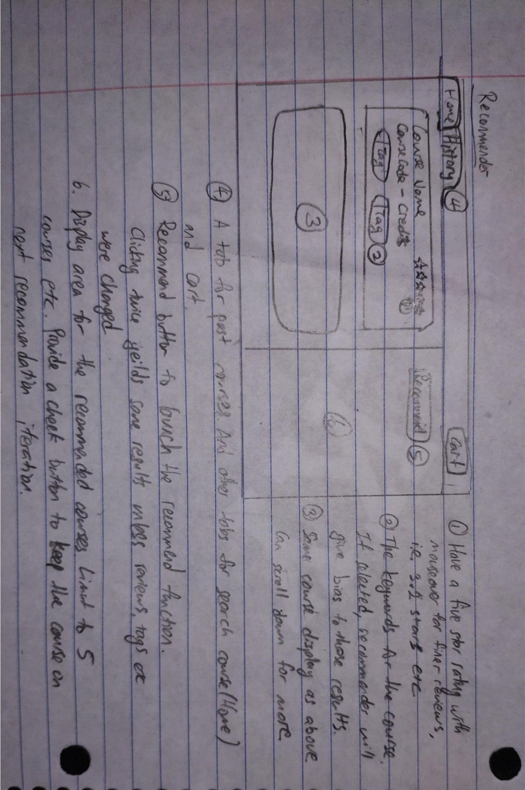**Step 1. Conceptual Design.** Choose one of the options for your application: *recommender* or *planner*. After reviewing the design specifications in the React 3 README, ideate on how it will work and sketch a conceptual design of the application. Your conceptual design can be hand-drawn or in the form of a digital wireframe (e.g., created in Adobe XD). Annotate your design to describe how the application will work and its main sections. Provide a photo or screenshot of your annotated design below.

<conceptual-design>

**Step 2. Information Structure.** Make a list of all the *content* that will be included in your design and displayed to the user, including content necessary to obtain user input, the output that your application will provide to your user, and other content that the user will need to effectively use your application. You can refer to previous lectures for discussion on Information Structure and Design Patterns for what kinds of elements/content your application might include. For each item in your list, provide a brief (2-to-3-sentence) description of the content, including the type of information included and its form (e.g., textual course description, shape that represents a class, a card that contains course information).

<content-elements>

Navigation Bar – Have a tab for home which is for search courses, the history tab which is for past courses taken and a cart button.

The History page – split in approximately half to show past courses and a space to show recommended courses.

The course Card – Displays the course name, code and credits, also holds the rating component and tags to give bias for recommender

Recommend Button – Clicks to show or reveal the recommended courses based on similarities with past courses with bias towards rating and tags.

Recommended courses – Show the bare minimum information for the user to be able to search it up in the search tab. Displays name, code and credits and pre-requisites.

Rating stars – Displays as empty stars if the user didn’t rate it yet. Also can do finer reviews by clicking exactly at 3.2 point star etc.

**Step 3. Content Organization.** In this step, make decisions about how you will organize the content you described in the previous step on the application canvas. Specifically, make decisions about what will appear above and below the fold, whether there will be any content below the fold, whether the application will include multiple pages or a single page, and whether content that may not fit within a single page will be paginated or loaded using infinite scroll. For example, do you plan to show all recommended courses on a single page or show one on each page. If all courses are shown on a single page, will some of them be below the fold? If you are showing one course at a time, will you paginate the recommended courses or load more on the page as the user requests them? Provide a narrative description of your decisions and their justifications below.

<narrative-description-of-design-choices>

The navigation bar will be on top of the screen, since it is something frequently accessed. We can also fix its position on the page so that it will always be there when user scrolls.

The course cards on the course history will be a column of cards, in which the user can scroll through the cards. Cards will be below the fold but since they are of equal importance, there isn’t a big benefit in putting them before or after the fold.

The recommended courses will be above the fold. However, there will be a limit on space therefore there will only be 5 recommended courses that will be shown. 5 is a good number in this assignment because any more than that and it is very likely that all available courses will be shown instead. It is also important to note that the recommending algorithm is bias based and doesn’t filter out courses that didn’t fit specifications.

Clicking on the recommended course card will show a pop-up modal to show all the details of the course.

If the table showing the lecture sections and subsections fit the window, then all info are displayed to the user, if not, then the table will be below the fold, giving priorities to the course name, code, credits, pre-requisites and description

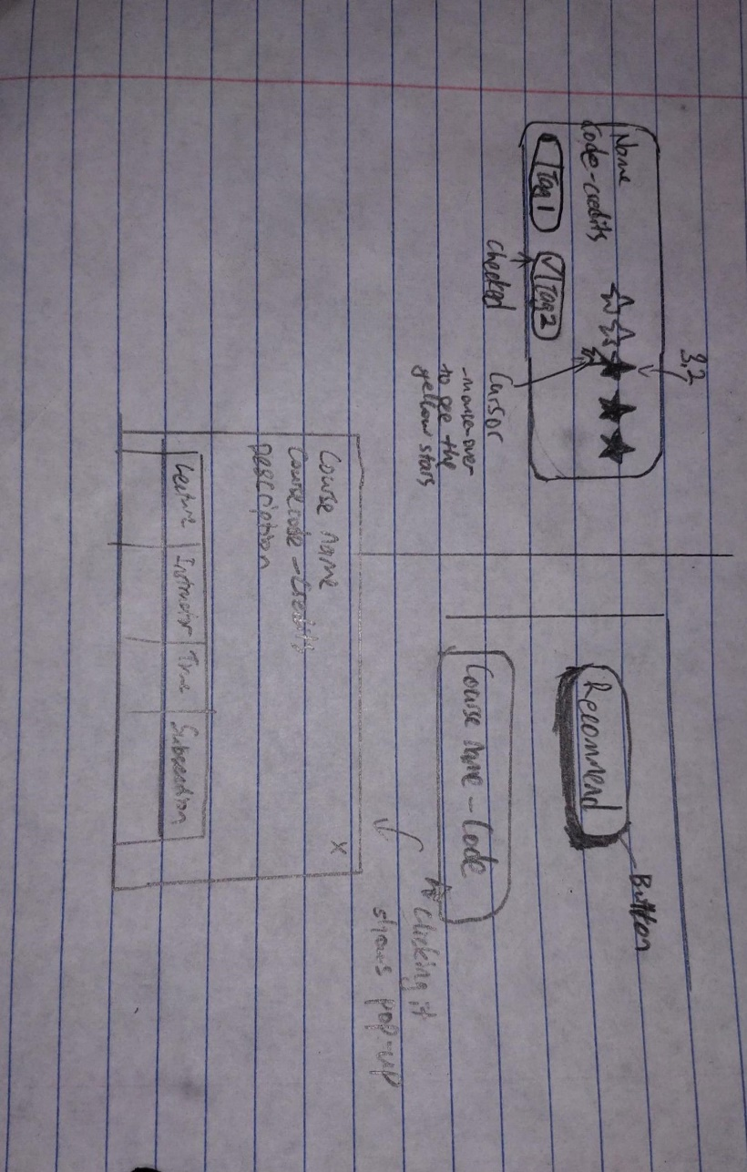**Step 4. Navigation Aids.** Determine what navigation aids will be necessary for the user to effectively use and navigate through your application. For example, if the user is reviewing multiple recommended courses or multiple course plans, how you envision the user to navigate through them? Do you need a menu that reflects the main sections of your application or the steps of the process users must follow? Create a hand- or digitally drawn mock-up of your application that illustrates the decisions you made in Steps 3 and 4 and annotate pieces of content and navigation aids.

<mock-up-illustrating-content-organization-and-navigation-aids>

Other than the Recommend button which is perceptible affordance, most designs are hidden affordances, the rating stars are blacked out unless clicked and the tags are just with empty boxes, unless stated or taught, user wouldn’t know that they are for the recommendation function. Clicking the names for more detail under the recommendation part is also a hidden affordance.

**Step 5. Component Hierarchy.** In this final step, review the mock-up you created in the previous step and describe the component hierarchy that you expect your application will have in its implementation. Review React 2 lecture for example hierarchies. An example/template is also provided below. Include a one-sentence description of each component. The output of this step will be the input into your React 3 assignment and guide the development of your application.

<component-hierarchy>

Recommender – A tab component for the App.js to house the History Component and Recommender

History – displays the past courses taken by the user

Rate – Lets the user rates the course

Tags – Shows a couple of tags so that the user can select for the recommender

Recommend – A button to generate a list of recommended courses

Generator – Reads the tag and rating information to generate a list of course (Rearranging a list of courses/Sorting)

CoursePopUp – Shows all the course details as a popup window.